# Cochise School District No. 26

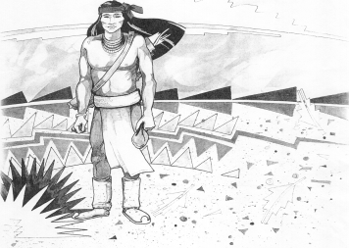

5025 N. Bowie Ave.

P.O. Box 1088

Cochise, AZ 85606

(520) 384-2540 (520) 384-4836 Fax

*Karl Uterhardt, Superintendent*

NOTICE & AGENDA OF GOVERNING BOARD MEETING

COCHISE ELEMENTARY SCHOOL DISTRICT NO. 26

Notice is hereby given that the School District Governing Board will hold a public meeting on

May 7, 2025, at 6:00pm in the Cochise Elementary School Library.

The agenda for the meeting is as follows:

I. Call to Order Time _________

1. Pledge of Allegiance to the Flag
2. Adoption of Agenda Motion ____/____Vote____
3. Call to the Audience (3 minute limit)
4. The Governing Board may vote to go into Executive Session under A.R.S. 38-431.03 (A)(3) to receive legal advice either in person or telephonically, on any item on the Consent or Action agenda.

VI. Consent Agenda

1. Approve minutes of Regular Meeting of April 2, 2025
2. Approve fund balances report for April 2025
3. Approve vouchers #21-22 (Payroll) & #2521-2522 (Expense) Motion ____/____Vote____

1. Action Agenda
2. Approve FY25 Expenditure Budget revision #1 Motion____/____ Vote____
3. Approve policy advisories 809-818 second reading Motion____/____ Vote____
4. Approve Ms. Marissa Paz, SPED paraeducator Motion____/____ Vote____
5. Approve Superintendent Performance Pay FY25 Motion____/____ Vote____
6. Presentation by Mrs. Cristi Swan, for Cochise School Audit FY24 Discussion Only
7. Approve Cochise School Financial Audit for Fiscal Year 2024 Motion____/____ Vote____
8. Approve Continuing Resolution with the Cochise County Treasurer Motion____/____ Vote____
9. Approve Classroom site fund payment for teachers May 23, 2025 Motion____/____ Vote____

VIII. Summary of reports about current events

A. Superintendent’s Report

1. May calendar of events: Staff student VB game 5/16, School field day 5/20; Kinder & 4th promotion 5/21 1pm; 8th grade promotion 5/22 4pm; last day of school 5/23

2. Next Board meetings: June 25, July 9, August 6

3. AASA & AzSCI testing update

B. Governing Board member’s report

IX. Adjourn Motion ____/____Vote____ Time ____