# Cochise School District No. 26

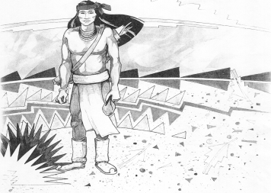

5025 N. Bowie Ave.

P.O. Box 1088

Cochise, AZ 85606

(520) 384-2540 (520) 384-4836 Fax

*Karl Uterhardt, Superintendent*

NOTICE & AGENDA OF GOVERNING BOARD MEETING

COCHISE ELEMENTARY SCHOOL DISTRICT NO. 26

Notice is hereby given that the School District Governing Board will hold a public meeting on

March 1, 2023, at 6:00pm in the Cochise Elementary School Library.

The agenda for the meeting is as follows:

I. Call to Order Time _________

1. Pledge of Allegiance to the Flag
2. Adoption of Agenda Motion ____/____Vote____
3. Call to the Audience (3 minute limit)
4. The Governing Board may vote to go into Executive Session under A.R.S. 38-431.03 (A)(3) to receive legal advice either in person or telephonically, on any item on the Consent or Action agenda.

VI. Consent Agenda

1. Approve minutes of Regular Meeting of February 1, 2023
2. Approve fund balances report for February 2023
3. Approve vouchers #17-18 (Payroll) & #2015-2016 (Expense) Motion ____/____Vote____

1. Action Agenda
2. Mrs. Inez Graham 3rd grade teacher Discussion Only
3. Approve Policy Advisories 741 & 742 second reading Motion____/____ Vote____
4. Approve June 21 Governing Board meeting date Motion____/____ Vote____
5. Approve General Statement of Assurance Motion____/____ Vote____
6. Approve Continuing Resolution with the Cochise County Treasurer Motion____/____ Vote____

VIII. Summary of reports about current events

A. Superintendent’s Report

1. March calendar of events:

2. Next Board meetings: April 5, May 3, June 21

3. Aggregate Expenditure Limited approved by the State

4. La Frontera Drug Prevention program

B. Governing Board member’s report

IX. Adjourn Motion ____/____Vote____ Time ____