# Cochise School District No. 26

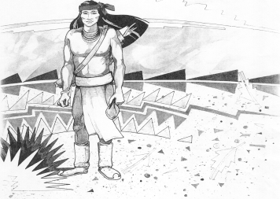

5025 N. Bowie Ave.

P.O. Box 1088

Cochise, AZ 85606

(520) 384-2540 (520) 384-4836 Fax

*Karl Uterhardt, Superintendent*

NOTICE & AGENDA OF GOVERNING BOARD MEETING

COCHISE ELEMENTARY SCHOOL DISTRICT NO. 26

**Notice is hereby given that the School District Governing Board will hold a public meeting on**

**January 10, 2018 at 6:30 pm in the media center. The agenda for the meeting is as follows:**

I. Call to Order Time _________

1. Pledge of Allegiance to the Flag
2. Election of Board President

Nominee:_________________________ Motion____/____ Vote____

1. Adoption of Agenda Motion ____/____Vote____

V. Call to the Audience (3 minute limit)

The Governing Board may vote to go into Executive Session under A.R.S. §38-431.03 (A)(3) to receive legal advice, either in person or telephonically, on any item on the Consent or Action agenda.

VI. Consent Agenda

A. Approve minutes of Regular Meeting of December 6, 2017

B. Approve fund balances report for December 2017

C. Approve vouchers #12-13 (Payroll) & #1811-1812 (Expense)

D. First Reading JFB Open Enrollment Policy Motion ____/____Vote____

VII. Action Agenda

1. Approve Resolution for Execution of Warrants between Meetings Motion____/____ Vote____
2. Establish Date, Time & Location for Regular Board Meetings Motion____/____ Vote____
3. Approval of Chase bank revolving line of credit Motion____/____ Vote____
4. Discussion of Board self-evaluation (Discussion only)
5. Approval of Board self-evaluation Motion____/____ Vote____

VIII. Summary of reports about current events

A. Superintendent’s Report

1. January calendar of events

B. Governing Board member’s report

IX. Adjourn Motion ____/____Vote____ Time ____