# Cochise School District No. 26

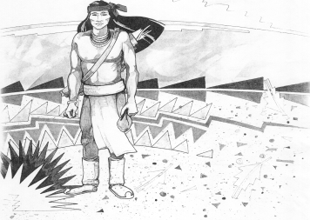

5025 N. Bowie Ave.

P.O. Box 1088

Cochise, AZ 85606

(520) 384-2540 (520) 384-4836 Fax

*Karl Uterhardt, Superintendent*

NOTICE & AGENDA OF GOVERNING BOARD MEETING

COCHISE ELEMENTARY SCHOOL DISTRICT NO. 26

**Notice is hereby given that the School District Governing Board will hold a public meeting on**

**June 27, 2018 at 6:30 pm in the media center. The agenda for the meeting is as follows:**

I. Call to Order Time _________

1. Pledge of Allegiance to the Flag
2. Adoption of Agenda Motion ____/____Vote____
3. Call to the Audience (3 minute limit)
4. The Governing Board may vote to go into Executive Session under A.R.S. §38-431.03 (A)(3) to receive legal advice, either in person or telephonically, on any item on the Consent or Action agenda.

VI. Consent Agenda

1. Approve minutes of Regular Meeting of May 2, 2018

B. Approve fund balances report for May 2018

C. Approve vouchers #23-29 (Payroll) & #1821-1824 (Expense) Motion ____/____Vote____

VII. Action Agenda

1. Approval of Mr. Uterhardt’s Performance Pay 2017-18 goal #3 pay Motion____/____ Vote____
2. Approval to open a bank account at Western Bank, Willcox Motion____/____ Vote____
3. Approval of St. David Consortium IGA for SPED and related services Motion____/____ Vote____
4. Discussion of possible playground equipment bid process (Discussion Only)
5. Approval of bid process or bid for playground equipment Motion____/____ Vote____
6. Approval of FY2018-19 Proposed Expenditure Budget Motion____/____ Vote____
7. Approval of David Michael, music teacher Motion____/____ Vote____

VIII. Summary of reports about current events

A. Superintendent’s Report

* 1. Update on summer projects
  2. School closed July 4th
  3. Future Board meetings: July 11, 2018, August 1, 2018, September 5, 2018

B. Governing Board member’s report

IX. Adjourn Motion ____/____Vote____ Time ____