# Cochise School District No. 26

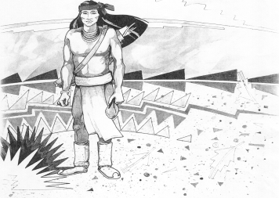

5025 N. Bowie Ave.

P.O. Box 1088

Cochise, AZ 85606

(520) 384-2540 (520) 384-4836 Fax

*Karl Uterhardt, Superintendent*

NOTICE & AGENDA OF GOVERNING BOARD MEETING

COCHISE ELEMENTARY SCHOOL DISTRICT NO. 26

Notice is hereby given that the School District Governing Board will hold a public meeting on

December 6, 2017 at 6:30 pm in the media center. The agenda for the meeting is as follows:

I. Call to Order Time _________

1. Pledge of Allegiance to the Flag
2. Adoption of Agenda Motion ____/____Vote____

IV. Call to the Audience (3 minute limit)

V. The Governing Board may vote to go into Executive Session under A.R.S. §38-431.03 (A)(3) to receive legal advice, either in person or telephonically, on any item on the Consent or Action agenda.

VI. Consent Agenda

1. Approve minutes of Regular Meeting of November 1, 2017
2. Approve fund balances report for November 2017
3. Approve vouchers #10-11 (Payroll) & #1808-1810 (Expense) Motion ____/____Vote____

VII. Action Agenda

1. Discussion/Action for uncompensated work payment for all staff members not eligible for the Classroom Site Fund monies in the amount of $300.00 per employee. Eligible employees: Maintenance, custodial, paraprofessional, food service, bus drivers, and administrative. Motion____/____ Vote____
2. Discussion/Action for payment to eligible teachers for the Classroom Site Fund Monies in the amount of $1,150.00 per teacher Motion____/____ Vote____
3. Discussion Action for FY2016 Financial Audit Motion____/____ Vote____
4. Pursuant to A.R.S. § 38-431.03(A)(1), the Governing Board may vote to enter executive session in order to discuss providing Superintendent Karl Uterhardt with proposed Superintendent evaluation for 2017-2018.  No action shall be taken within this executive session. Motion____/____ Vote____
5. Discussion/Action Approval of the superintendent’s evaluation Motion____/____ Vote____
6. Discussion SW property auction of building/cleanup of property
7. Discuss/Action regarding security hardware Motion____/____ Vote____

VIII. Summary of reports about current events

A. Superintendent’s Report

1. December calendar of events

B. Governing Board member’s report

IX. Adjourn Motion ____/____Vote____ Time ____