# Cochise School District No. 26

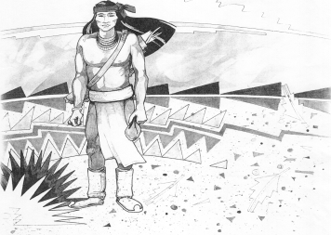

5025 N. Bowie Ave.

P.O. Box 1088

Cochise, AZ 85606

(520) 384-2540 (520) 384-4836 Fax

*Karl Uterhardt, Superintendent*

PUBLIC HEARING

In accordance with A.R.S. §15-905 notice is hereby given that the

2023-2024 Adopted Expenditure Budget Hearing for Cochise School District, 02-03-26,

will be July 12, 2023, 6:00 P.M. in the media center.

I. Call to Order Time _____

1. Public Hearing for Adopted Budget

Open Public Hearing Motion ____/____Vote____

Close Public Hearing Motion ____/____Vote____

III. Adjourn Motion ____/____Vote____ Time: ________

NOTICE & AGENDA OF GOVERNING BOARD MEETING

COCHISE ELEMENTARY SCHOOL DISTRICT NO. 26

Notice is hereby given that the School District Governing Board will hold a public meeting on

July 12, 2023 following the public hearing in the media center, approximately 6:05pm.

The agenda for the meeting is as follows:

I. Call to Order Time _________

1. Pledge of Allegiance to the Flag
2. Adoption of Agenda Motion ____/____Vote____

IV. Call to the Audience (3 minute limit) Motion ____/____Vote____

1. The Governing Board may vote to go into Executive Session under A.R.S. 38-431.03 (A)(3) to receive legal advice either in person or telephonically, on any item on the Consent or Action agenda

VI. Consent Agenda

1. Approve minutes of Regular Meeting of June 21, 2023
2. Approve fund balances report for June 2023
3. Approve vouchers Payroll 27-29 & #1 Expenditure #2325 Motion ____/____Vote____

VII. Action Agenda

1. Approve FY23/24 Expenditure Budget Motion____/____ Vote____
2. Discussion of SPED for 2023-24 Motion____/____ Vote____
3. Discussion/Action bus purchase for SY23-24 Motion____/____ Vote____
4. Gym Floor update Discussion Only
5. Approve Sole Source Vendors – ASBAIT Valley Telecommunications

Follett Library Services Pearson/Powerschool Tyler Technologies

Arizona School Risk Retention-The Trust KnowAtom Motion ____/____Vote____

VIII. Summary of reports about current events

A. Superintendent’s Report

1. August calendar of events-School starts August 9, Meet the teacher night August 10, 4-6pm

2. Future board meeting dates: August 2, September 6, October 4

B. Governing Board member’s report

IX. Adjourn Motion ____/____Vote____ Time ____