# Cochise School District No. 26

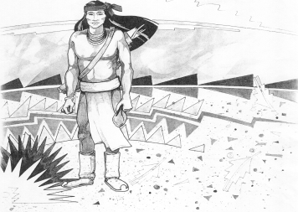

5025 N. Bowie Ave.

P.O. Box 1088

Cochise, AZ 85606

(520) 384-2540 (520) 384-4836 Fax

*Karl Uterhardt, Superintendent*

NOTICE & AGENDA OF GOVERNING BOARD MEETING

COCHISE ELEMENTARY SCHOOL DISTRICT NO. 26

Notice is hereby given that the School District Governing Board will hold a public meeting on

June 21, 2023, at 6:00pm in the Cochise Elementary School Library.

The agenda for the meeting is as follows:

I. Call to Order Time _________

1. Pledge of Allegiance to the Flag
2. Adoption of Agenda Motion ____/____Vote____
3. Call to the Audience (3 minute limit)
4. The Governing Board may vote to go into Executive Session under A.R.S. 38-431.03 (A)(3) to receive legal advice either in person or telephonically, on any item on the Consent or Action agenda.

VI. Consent Agenda

1. Approve minutes of Regular Meeting of May 3, 2023
2. Approve fund balances report for May 2023
3. Approve vouchers #23-26 (Payroll) & #2321-2324 (Expense) Motion ____/____Vote____

1. Action Agenda
2. Mrs. Tina Rone discussion on a special education issue Discussion Only
3. Approval of FY24 Proposed Budget Motion____/____ Vote____
4. Approve St. David Consortium SY23-24 Motion____/____ Vote____
5. Approval of Bus Repair RFP bids for SY23-24 Motion____/____ Vote____
6. Approval of IT services RFP bids for SY23-24, 24-25, & 25-26 Motion____/____ Vote____
7. Discussion of 77 passenger bus for school Discussion Only
8. Approval of 77 passenger bus purchase (Canyon State or RWC) Motion____/____ Vote____
9. AASA testing update Discussion Only

VIII. Summary of reports about current events

A. Superintendent’s Report

1. June calendar of events:

2. Next Board meetings: July 12, August 2, September 6

B. Governing Board member’s report

IX. Adjourn Motion ____/____Vote____ Time ____