# Cochise School District No. 26

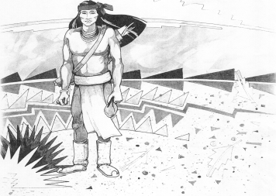

5025 N. Bowie Ave.

P.O. Box 1088

Cochise, AZ 85606

(520) 384-2540 (520) 384-4836 Fax

*Karl Uterhardt, Superintendent*

NOTICE & AGENDA OF GOVERNING BOARD MEETING

COCHISE ELEMENTARY SCHOOL DISTRICT NO. 26

Notice is hereby given that the School District Governing Board will hold a public meeting on

November 1, 2023, at 6:00pm in the Cochise Elementary School Library.

The agenda for the meeting is as follows:

I. Call to Order Time _________

1. Pledge of Allegiance to the Flag
2. Adoption of Agenda Motion ____/____Vote____

IV. Call to the Audience (3 minute limit)

1. The Governing Board may vote to go into Executive Session under A.R.S. 38-431.03 (A)(3) to receive legal advice either in person or telephonically, on any item on the Consent or Action agenda

VI. Consent Agenda

1. Approve minutes of Regular Meeting of October 4, 2023
2. Approve fund balances report for October 2023
3. Approve vouchers Payroll #8-9 and Expenditure #2405-2406 Motion ____/____Vote____

VII. Action Agenda

1. Mrs. Lori White 3rd grade teacher Discussion Only
2. Discussion/Action second reading of policy advisories 744-746 Motion____/____ Vote____
3. Approval of Classroom Site Fund for 2023-2024 Motion____/____ Vote____
4. Reminder of Superintendent Evaluation due by Dec. 31, 2023 Discussion Only
5. Discussion/Action support or non-support of proposed solar field Motion____/____ Vote____

VIII. Summary of reports about current events

A. Superintendent’s Report

1. November Calendar of events: Volleyball results, Glow Walk November 9, 530-730pm; November 10, school closed; November 22,23, 24 Thanksgiving holiday school closed. December 1st our first home BB game

2. Future board meeting dates: December 6, January 10, February 6

B. Governing Board member’s report

IX. Adjourn Motion ____/____Vote____ Time ____