# Cochise School District No. 26

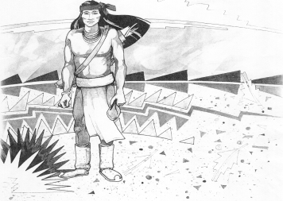

5025 N. Bowie Ave.

P.O. Box 1088

Cochise, AZ 85606

(520) 384-2540 (520) 384-4836 Fax

*Karl Uterhardt, Superintendent*

NOTICE & AGENDA OF GOVERNING BOARD MEETING

COCHISE ELEMENTARY SCHOOL DISTRICT NO. 26

Notice is hereby given that the School District Governing Board will hold a public meeting on

October 4, 2023, at 6:00pm in the Cochise Elementary School Library.

The agenda for the meeting is as follows:

I. Call to Order Time _________

1. Pledge of Allegiance to the Flag
2. Adoption of Agenda Motion ____/____Vote____

IV. Call to the Audience (3 minute limit)

1. The Governing Board may vote to go into Executive Session under A.R.S. 38-431.03 (A)(3) to receive legal advice either in person or telephonically, on any item on the Consent or Action agenda

VI. Consent Agenda

1. Approve minutes of Regular Meeting of September 6, 2023
2. Approve fund balances report for September 2023
3. Approve vouchers Payroll #6-7 and Expenditure #2403-2404
4. Approve first reading of policy advisories 744-746 Motion ____/____Vote____

VII. Action Agenda

1. Mrs. Cori Aten Kindergarten teacher Discussion Only
2. Discussion/Action on Bid for old water tank Motion____/____ Vote____
3. Discussion/Action FY23 Annual Financial Report Motion____/____ Vote____
4. Discussion/Action of response letter to ADOT Motion____/____ Vote____
5. Discussion/Action replacement of lights in classrooms by SiteLogic Motion____/____ Vote____
6. Gym floor update Discussion Only

VIII. Summary of reports about current events

A. Superintendent’s Report

1. October calendar of events-Away VB games Oct. 17 & 20 girls tournament Oct. 27 @Cochise; boys tournament Oct. 28th in Pomereme; Fall Break Oct. 9-13th school and office closed.

2. Future board meeting dates: November 1, December 6, January 10

B. Governing Board member’s report

IX. Adjourn Motion ____/____Vote____ Time ____