# Cochise School District No. 26

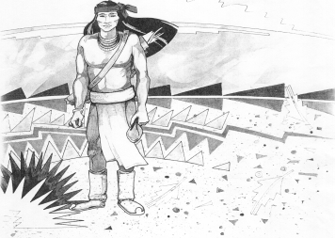

5025 N. Bowie Ave.

P.O. Box 1088

Cochise, AZ 85606

(520) 384-2540 (520) 384-4836 Fax

*Karl Uterhardt, Superintendent*

COCHISE ELEMENTARY SCHOOL DISTRICT NO. 26

Notice is hereby given that the School District Governing Board will hold a public meeting on

August 7, 2024 following the public hearing in the media center, approximately 6:05pm.

The agenda for the meeting is as follows:

I. Call to Order Time _________

1. Pledge of Allegiance to the Flag
2. Adoption of Agenda Motion ____/____Vote____

IV. Call to the Audience (3 minute limit)

1. The Governing Board may vote to go into Executive Session under A.R.S. 38-431.03 (A)(3) to receive legal advice either in person or telephonically, on any item on the Consent or Action agenda

VI. Consent Agenda

1. Approve minutes of Regular Meeting of July 10, 2024
2. Approve fund balances report for July 2024
3. Approve vouchers Payroll #2-3 Expenditure #2502-2503 Motion ____/____Vote____

VII. Action Agenda

1. Approve AJ Brown part time custodian 2024-2025 Motion____/____ Vote____
2. Policy Advisories 763-786 Omitting 777 a high school requirement 2nd reading Motion____/____ Vote____

VIII. Summary of reports about current events

A. Superintendent’s Report

1. August calendar of events-School starts August 7, Meet the teacher night August 8, 4-6pm, VB game August 16, away, August 23 Home August 30, Away

2. Future board meeting dates: September 4, October 2, November 6

B. Governing Board member’s report

IX. Adjourn Motion ____/____Vote____ Time ____