# Cochise School District No. 26

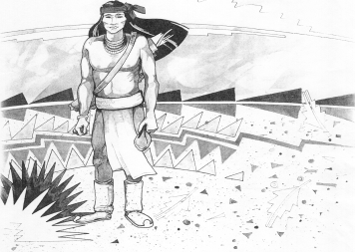

5025 N. Bowie Ave.

P.O. Box 1088

Cochise, AZ 85606

(520) 384-2540 (520) 384-4836 Fax

*Karl Uterhardt, Superintendent*

COCHISE ELEMENTARY SCHOOL DISTRICT NO. 26

Notice is hereby given that the School District Governing Board will hold a public meeting on

October 2, 2024 following the public hearing in the media center, approximately 6:05pm.

The agenda for the meeting is as follows:

I. Call to Order Time _________

1. Pledge of Allegiance to the Flag
2. Adoption of Agenda Motion ____/____Vote____

IV. Call to the Audience (3 minute limit)

1. The Governing Board may vote to go into Executive Session under A.R.S. 38-431.03 (A)(3) to receive legal advice either in person or telephonically, on any item on the Consent or Action agenda

VI. Consent Agenda

1. Approve minutes of Regular Meeting of September 4, 2024
2. Approve fund balances report for September 2024
3. Approve policy advisories 801-807 First reading
4. Approve vouchers Payroll #6-7 and Expenditure #2506-2507 Motion ____/____Vote____

VII. Action Agenda

1. Mrs. Terry Cavey & Mrs. Cheri Williammee bus drivers Discussion Only
2. Approve FY24 Annual Financial Report (AFR) Motion____/____ Vote____
3. Approve Mrs. Marie Spitzer, part time custodian Motion____/____ Vote____
4. Approve Policy Advisories 788-800 Second reading (Omit 796 HS Grad) Motion____/____ Vote____

VIII. Summary of reports about current events

A. Superintendent’s Report

1. October calendar of events-Volleyball game schedule, Parent/Teacher conf. Oct. 3 1-6pm, no school October 7-11 fall break, Boys VB tourney Oct. 26 @Cochise, Halloween parade Oct. 31st.

2. Future board meeting dates: November 6, December 4, January 8, 2025

B. Governing Board member’s report

IX. Adjourn Motion ____/____Vote____ Time ____