# Cochise School District No. 26

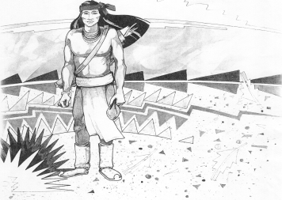

5025 N. Bowie Ave.

P.O. Box 1088

Cochise, AZ 85606

(520) 384-2540 (520) 384-4836 Fax

*Karl Uterhardt, Superintendent*

NOTICE & AGENDA OF GOVERNING BOARD MEETING

COCHISE ELEMENTARY SCHOOL DISTRICT NO. 26

**Notice is hereby given that the School District Governing Board will hold a public meeting on**

**March 7, 2018 at 6:30 pm in the media center. The agenda for the meeting is as follows:**

I. Call to Order Time _________

1. Pledge of Allegiance to the Flag
2. Adoption of Agenda Motion ____/____Vote____
3. Call to the Audience (3 minute limit)
4. The Governing Board may vote to go into Executive Session under A.R.S. §38-431.03 (A)(3) to receive legal advice, either in person or telephonically, on any item on the Consent or Action agenda.

VI. Consent Agenda

A. Approve minutes of Regular Meeting of February 7, 2018

B. Approve fund balances report for February 2018

C. Approve vouchers #17-18 (Payroll) & #1815-1816 (Expense)

D. Approve policy advisories 602-605, 607, 609-615 first reading

E. Approve retirement of Ms. Barbi Kruse, bus driver effective 5/25/18 Motion ____/____Vote____

VII. Action Agenda

1. Discussion of possible staff raises for the 2018-19 school year (Discussion Only)
2. Approval of staff raises for 2018-19 school year Motion____/____ Vote____
3. Approval of calendar for 2018-19 school year Motion____/____ Vote____
4. Approval of first reading of policy JFB Open Enrollment Motion____/____ Vote____
5. Approval of Medical insurance for 2018-19 Motion____/____ Vote____
6. Discussion/Approval of student life tour Motion____/____ Vote____

VIII. Summary of reports about current events

A. Superintendent’s Report

1. March calendar of events

2. Auditor General annual financial analysis

B. Governing Board member’s report

IX. Adjourn Motion ____/____Vote____ Time ____