# Cochise School District No. 26

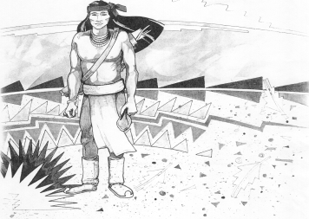

5025 N. Bowie Ave.

P.O. Box 1088

Cochise, AZ 85606

(520) 384-2540 (520) 384-4836 Fax

*Karl Uterhardt, Superintendent*

NOTICE & AGENDA OF GOVERNING BOARD MEETING

COCHISE ELEMENTARY SCHOOL DISTRICT NO. 26

Notice is hereby given that the School District Governing Board will hold a public meeting on

February 7, 2024, at 6:00pm in the Cochise Elementary School Library.

The agenda for the meeting is as follows:

1. Call to Order Time _________
2. Pledge of Allegiance to the Flag
3. Adoption of Agenda Motion ____/____Vote____
4. Call to the Audience (3 minute limit)
5. The Governing Board may vote to go into Executive Session under A.R.S. 38-431.03 (A)(3) to receive legal advice either in person or telephonically, on any item on the Consent or Action agenda.

VII. Consent Agenda

1. Approve minutes of Regular Meeting of January 10, 2024
2. Approve fund balances report for January 2024
3. Approve vouchers #14-16 (Payroll) & #2312-2314 (Expense) Motion ____/____Vote____

1. Action Agenda
2. Mrs. Tara Gibson, ADOT Community Relations Project Manager, to discuss

the repair of the 191 overpass Discussion Only

1. Approve policy advisories 748-762 second reading Motion____/____ Vote____
2. Approve school calendar for the 2024-2025 school year Motion____/____ Vote____
3. Approve Ms. Maria Hirshouer, Teacher for 2024-2025 school year Motion____/____ Vote____

IX. Summary of reports about current events

A. Superintendent’s Report

1. February calendar of events: PTO movie night 2/9, BB away 2/19 & 2/23, Presidents day no school 2/19

2. Next Board meetings: March 6, April 3, May 1

B. Governing Board member’s report

X. Adjourn Motion ____/____Vote____ Time ____