# Cochise School District No. 26

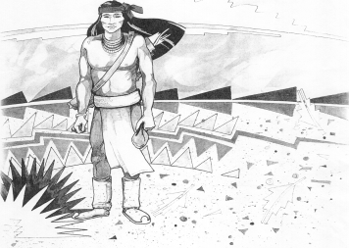

5025 N. Bowie Ave.

P.O. Box 1088

Cochise, AZ 85606

(520) 384-2540 (520) 384-4836 Fax

*Karl Uterhardt, Superintendent*

NOTICE & AGENDA OF GOVERNING BOARD MEETING

COCHISE ELEMENTARY SCHOOL DISTRICT NO. 26

Notice is hereby given that the School District Governing Board will hold a public meeting on

June 26, 2024, at 6:00pm in the Cochise Elementary School Library.

The agenda for the meeting is as follows:

I. Call to Order Time _________

1. Pledge of Allegiance to the Flag
2. Adoption of Agenda Motion ____/____Vote____
3. Call to the Audience (3 minute limit)
4. The Governing Board may vote to go into Executive Session under A.R.S. 38-431.03 (A)(3) to receive legal advice either in person or telephonically, on any item on the Consent or Action agenda.

VI. Consent Agenda

1. Approve minutes of Regular Meeting of May 1, 2024
2. Approve fund balances report for May 2024
3. Approve vouchers # (Payroll) & # (Expense) Motion ____/____Vote____

1. Action Agenda
2. Approval of FY25 Proposed Budget Motion____/____ Vote____
3. Approval of Joaquin Ochoa sick leave buy back (retiring) Motion____/____ Vote____
4. Approve St. David Consortium SY24-25 Motion____/____ Vote____
5. Approval of Bus Repair RFP bids for SY24-25 Motion____/____ Vote____
6. Approval of Fence Bid SE property Motion____/____ Vote____

VIII. Summary of reports about current events

A. Superintendent’s Report

1. June calendar of events:

2. Next Board meetings: July 10, August 7, September 4

B. Governing Board member’s report

IX. Adjourn Motion ____/____Vote____ Time ____