# Cochise School District No. 26

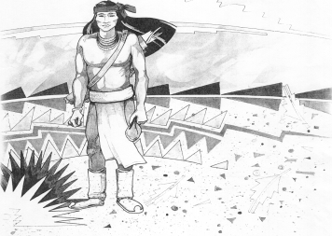

5025 N. Bowie Ave.

P.O. Box 1088

Cochise, AZ 85606

(520) 384-2540 (520) 384-4836 Fax

*Karl Uterhardt, Superintendent*

NOTICE & AGENDA OF GOVERNING BOARD MEETING

COCHISE ELEMENTARY SCHOOL DISTRICT NO. 26

Notice is hereby given that the School District Governing Board will hold a public meeting on

March 5, 2025, at 6:00pm in the Cochise Elementary School Library.

The agenda for the meeting is as follows:

I. Call to Order Time _________

1. Pledge of Allegiance to the Flag
2. Adoption of Agenda Motion ____/____Vote____
3. Call to the Audience (3 minute limit)
4. The Governing Board may vote to go into Executive Session under A.R.S. 38-431.03 (A)(3) to receive legal advice either in person or telephonically, on any item on the Consent or Action agenda.

VI. Consent Agenda

1. Approve minutes of Regular Meeting of February 5, 2025
2. Approve fund balances report for February 2025
3. Approve 2025-2026 school calendar
4. Approve vouchers #18-19 (Payroll) & #2516-2417 (Expense) Motion ____/____Vote____

1. Action Agenda
2. Mr. Robert Spitzer, English teacher Discussion Only
3. Approve Mr. Robert Spitzer’s retirement from Cochise School effective

May 22, 2026 Motion____/____ Vote____

1. Approve June 2025 Board meeting date of June 25, 2025 Motion____/____ Vote____
2. Approve General Statement of Assurance. Motion____/____ Vote____
3. Approve medical, dental, vision plan for 2025-2026 school year Motion____/____ Vote____
4. Approve contribution amount for insurance for 2025-2026 school year. Motion____/____ Vote____
5. Approve Mrs. Cori Aten retirement effective August 1, 2025 Motion____/____ Vote____
6. Approval of Mrs. Aten to continue to work for Cochise ESD under the

Educational Services Inc. (ESI) for the 2025-2026 school year Motion____/____ Vote____

1. Approve Mrs. Tina Rone, resignation effective May 23, 2025 Motion____/____ Vote____
2. Approve Mrs. Bernadette Martinez, elementary school teacher 2025-2026 Motion____/____ Vote____

VIII. Summary of reports about current events

A. Superintendent’s Report

1. March calendar of events: March 6 PT conferences, March 7 early release March 10-14 Spring Break

2. Next Board meetings: April 2, May 7, June 25

B. Governing Board member’s report

IX. Adjourn Motion ____/____Vote____ Time ____