# Cochise School District No. 26

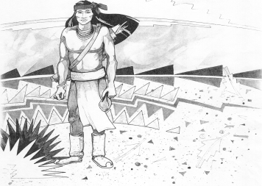

5025 N. Bowie Ave.

P.O. Box 1088

Cochise, AZ 85606

(520) 384-2540 (520) 384-4836 Fax

*Karl Uterhardt, Superintendent*

NOTICE & AGENDA OF GOVERNING BOARD MEETING

COCHISE ELEMENTARY SCHOOL DISTRICT NO. 26

Notice is hereby given that the School District Governing Board will hold a public meeting on

January 10, 2024, at 6:00pm in the Cochise Elementary School Library.

The agenda for the meeting is as follows:

1. Call to Order Time _________
2. Pledge of Allegiance to the Flag
3. Election of Board President, Nominee___________________________ Motion____/____ Vote____
4. Adoption of Agenda Motion ____/____Vote____
5. Call to the Audience (3 minute limit)
6. The Governing Board may vote to go into Executive Session under A.R.S. 38-431.03 (A)(3) to receive legal advice either in person or telephonically, on any item on the Consent or Action agenda.

VII. Consent Agenda

1. Approve minutes of Regular Meeting of December 6, 2023
2. Approve fund balances report for December 2026
3. Approve 60 day review for Wonders 2023 by McGraw Hill Reading program Grades K-5
4. Policy Advisories 748-762 first reading
5. Resignation of Mrs. Ky’Leigh Purcell effective January 8, 2024
6. Approve vouchers #12-13 (Payroll) & #2310-2311 (Expense) Motion ____/____Vote____

1. Action Agenda
2. Mrs. Tara Gibson, ADOT Community Relations Project Manager, to discuss

the repair of the 191 overpass Discussion Only

1. Approve Resolution for Execution of Warrants between Meetings Motion____/____ Vote____
2. Establish Date, Time & Location for Regular Board Meetings Motion____/____ Vote____

IX. Summary of reports about current events

A. Superintendent’s Report

1. January calendar of events:

2. Next Board meetings: February 7, March 6, April 3

B. Governing Board member’s report

X. Adjourn Motion ____/____Vote____ Time ____