# Cochise School District No. 26

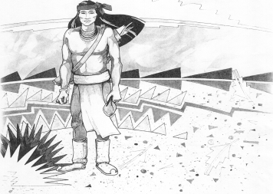

5025 N. Bowie Ave.

P.O. Box 1088

Cochise, AZ 85606

(520) 384-2540 (520) 384-4836 Fax

*Karl Uterhardt, Superintendent*

NOTICE & AGENDA OF GOVERNING BOARD MEETING

COCHISE ELEMENTARY SCHOOL DISTRICT NO. 26

Notice is hereby given that the School District Governing Board will hold a public meeting on

April 2, 2025, at 6:00pm in the Cochise Elementary School Library.

The agenda for the meeting is as follows:

I. Call to Order Time _________

1. Pledge of Allegiance to the Flag
2. Adoption of Agenda Motion ____/____Vote____
3. Call to the Audience (3 minute limit)
4. The Governing Board may vote to go into Executive Session under A.R.S. 38-431.03 (A)(3) to receive legal advice either in person or telephonically, on any item on the Consent or Action agenda.

VI. Consent Agenda

1. Approve minutes of Regular Meeting of March 5, 2025
2. Approve fund balances report for March 2025
3. Approve vouchers #19-20 (Payroll) & #2519-2520 (Expense)
4. Approve policy advisories 809-818 first reading
5. Approve Mrs. Mascarenas extra duty contract Knowledge Bowl
6. Authorization to dispose of district property: Cafeteria Freezer Motion ____/____Vote____

1. Action Agenda
2. Mrs. Tina Rone, 1st grade teacher Discussion Only
3. Approve raise of $1,000.00 for all full-time staff members Motion____/____ Vote____
4. Approve contract for Mr. Uterhardt, Superintendent for the

2026-2027, 2027-2028, & 2028-2029 school years Motion____/____ Vote____

1. Approve FY26 contract for Ms. Candy Acuna, Business Manager Motion____/____ Vote____
2. Approve FY26 certified teaching contracts for:

Mrs. White, Mrs. Graham, Ms. Estrella, Mr. Ochoa, Ms. Hirshouer,

Mrs. Mascarenas, Mr. Spitzer, & Mrs. Oscar Motion____/____ Vote____

1. Approve FY26 non-certified Letters of Intent for:

Ms. Peterson, Mr. D. Brown, Mr. Morales, Mrs. Williammee, Mr. AJ Brown,

Mrs. Cavey, and Mrs. Leksell Motion____/____ Vote____

1. Approve Retirement of Mrs. Gina Nohl, Reading Interventionist

effective May 24, 2025. Motion____/____ Vote____

VIII. Summary of reports about current events

A. Superintendent’s Report

1. April calendar of events: AASA testing begins April 3, two track meets 4/3 & 4/29

2. Next Board meetings: May 7, June 25, July 9

B. Governing Board member’s report

IX. Adjourn Motion ____/____Vote____ Time ____