# Cochise School District No. 26

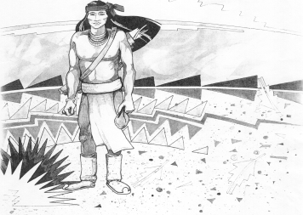

5025 N. Bowie Ave.

P.O. Box 1088

Cochise, AZ 85606

(520) 384-2540 (520) 384-4836 Fax

*Karl Uterhardt, Superintendent*

NOTICE & AGENDA OF GOVERNING BOARD MEETING

COCHISE ELEMENTARY SCHOOL DISTRICT NO. 26

**Notice is hereby given that the School District Governing Board will hold a public meeting on**

**February 7, 2018 at 6:30 pm in the media center. The agenda for the meeting is as follows:**

I. Call to Order Time _________

1. Pledge of Allegiance to the Flag
2. Adoption of Agenda Motion ____/____Vote____
3. Call to the Audience (3 minute limit)
4. The Governing Board may vote to go into Executive Session under A.R.S. §38-431.03 (A)(3) to receive legal advice, either in person or telephonically, on any item on the Consent or Action agenda.

VI. Consent Agenda

A. Approve minutes of Regular Meeting of January 10, 2018

B. Approve fund balances report for December 2017 & January 2018

C. Approve vouchers #14-16 (Payroll) & #1813-1814 (Expense)

D. Approve first reading of policy JFB Open Enrollment

E. Approve retirement of Mrs. Chris Stukel, Cafeteria manager

F. Approval resignation of Mrs. Vicky Brookman, Teacher

G. Approval of Mrs. Kay Deakman, Art Teacher for Spring Semester

H. Approval of resignation of Mrs. Stephani Salivar, Music teacher Motion ____/____Vote____

VII. Action Agenda

1. Discussion of possible staff raises for the 2018/19 school year (Discussion Only)
2. Approval of staff raises for 2018/19 school year Motion____/____Vote____
3. Discussion of possible purchase of property east of the school (Discussion Only)
4. Discussion of music teaching position for 2018/19 school year (Discussion Only)
5. Approval of bus repair bid quotes for 2017/18 & 2018/19 Motion____/____ Vote____
6. Approval of 60 day curriculum review-McGraw-Hill Reading Wonders K-5

books are available at the Cochise ESD #26 Library Motion____/____Vote____

VIII. Summary of reports about current events

A. Superintendent’s Report

1. February calendar of events

B. Governing Board member’s report

IX. Adjourn Motion ____/____Vote____ Time ____