# Cochise School District No. 26

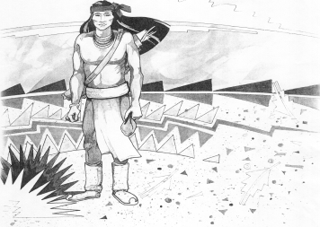

5025 N. Bowie Ave.

P.O. Box 1088

Cochise, AZ 85606

(520) 384-2540 (520) 384-4836 Fax

*Karl Uterhardt, Superintendent*

NOTICE & AGENDA OF GOVERNING BOARD MEETING

COCHISE ELEMENTARY SCHOOL DISTRICT NO. 26

Notice is hereby given that the School District Governing Board will hold a public meeting on

October 4, 2017 at 6:30 pm in the media center. The agenda for the meeting is as follows:

I. Call to Order Time _________

1. Pledge of Allegiance to the Flag
2. Adoption of Agenda Motion ____/____Vote____

IV. Call to the Audience (3 minute limit)

V.The Governing Board may vote to go into Executive Session under A.R.S. §38-431.03 (A)(3) to receive legal advice, either in person or telephonically, on any item on the Consent or Action agenda.

VI. Consent Agenda

1. Approve minutes of Regular Meeting of September 6, 2017
2. Approve fund balances report for September 2017
3. Approve vouchers #6-7 (Payroll) & #1804-1805 (Expense) Motion ____/____Vote____

VII. Action Agenda

1. Approve 2nd reading policy adv.#588-591, 594, 596, 598-600 Motion____/____ Vote____
2. Approval of Audit bid for FY2017-2020 Motion____/____ Vote____
3. Approval of Annual Financial Report FY17 Motion____/____ Vote____
4. Discussion/Approve cleanup of SW property Motion____/____ Vote____

VIII. Summary of reports about current events

A. Superintendent’s Report

1. October calendar of events

2. Superintendent and Board evaluations due by December 2017

B. Governing Board member’s report

IX. Adjourn Motion ____/____Vote____ Time ____