# Cochise School District No. 26

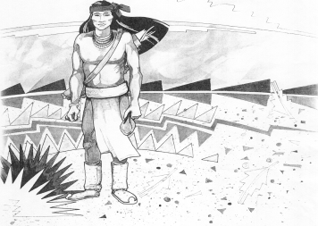

5025 N. Bowie Ave.

P.O. Box 1088

Cochise, AZ 85606

(520) 384-2540 (520) 384-4836 Fax

*Karl Uterhardt, Superintendent*

NOTICE & AGENDA OF GOVERNING BOARD MEETING

COCHISE ELEMENTARY SCHOOL DISTRICT NO. 26

Notice is hereby given that the School District Governing Board will hold a public meeting on

August 2, 2023 following the public hearing in the media center, approximately 6:05pm.

The agenda for the meeting is as follows:

I. Call to Order Time _________

1. Pledge of Allegiance to the Flag
2. Adoption of Agenda Motion ____/____Vote____

IV. Call to the Audience (3 minute limit)

1. The Governing Board may vote to go into Executive Session under A.R.S. 38-431.03 (A)(3) to receive legal advice either in person or telephonically, on any item on the Consent or Action agenda

VI. Consent Agenda

1. Approve minutes of Regular Meeting of July 12, 2023
2. Approve fund balances report for July 2023
3. Approve vouchers Payroll #2-#3 and Expenditure #2326 & #2400 Motion ____/____Vote____

VII. Action Agenda

1. Discussion of SPED for 2023-24 Motion____/____ Vote____
2. Discussion/Action approval of bus #6 trade in with Canyon State Bus Sales

to offset cost of new bus Motion____/____ Vote____

1. Discussion/Action of financing options for new bus Motion____/____ Vote____
2. Approve letter for Arizona State Highway Department to repair I-10 overpass

for Highway 191 Motion____/____ Vote____

VIII. Summary of reports about current events

A. Superintendent’s Report

1. August calendar of events-School starts August 9, Meet the teacher night August 10, 4-6pm, first VB game on August 18th @home

2. Future board meeting dates: September 6, October 4, November 1

B. Governing Board member’s report

IX. Adjourn Motion ____/____Vote____ Time ____