# Cochise School District No. 26

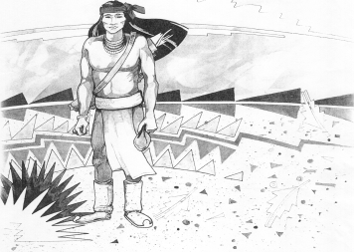

5025 N. Bowie Ave.

P.O. Box 1088

Cochise, AZ 85606

(520) 384-2540 (520) 384-4836 Fax

*Karl Uterhardt, Superintendent*

NOTICE & AGENDA OF GOVERNING BOARD MEETING

COCHISE ELEMENTARY SCHOOL DISTRICT NO. 26

Notice is hereby given that the School District Governing Board will hold a public meeting on

April 3, 2024, at 6:00pm in the Cochise Elementary School Library.

The agenda for the meeting is as follows:

I. Call to Order Time _________

1. Pledge of Allegiance to the Flag
2. Adoption of Agenda Motion ____/____Vote____
3. Call to the Audience (3 minute limit)
4. The Governing Board may vote to go into Executive Session under A.R.S. 38-431.03 (A)(3) to receive legal advice either in person or telephonically, on any item on the Consent or Action agenda.

VI. Consent Agenda

1. Approve minutes of Regular Meeting of March 6, 2024
2. Approve fund balances report for March 2024
3. Approve vouchers #19-20 (Payroll) & #2317-2319 (Expense)
4. Approve Cochise County Treasurer Continuing Investment Resolution Motion ____/____Vote____

1. Action Agenda
2. Mrs. Libby Wilson, Science teacher Discussion Only
3. Approve Reading Wonders program beginning school year 2024-25

and ending school year 2032-2033 school year. Motion____/____ Vote____

1. Approve purchase of Reading Wonders program for next 8 years Motion____/____ Vote____
2. Approve all staff raise of 5% for SY2024-2025 Motion____/____ Vote____
3. Approve FY25 district contribution for medical, dental & vision insurance Motion____/____ Vote____
4. Approve contract for Ms. Candy Acuna, Business Manager Motion____/____ Vote____
5. Approve certified teaching contracts for:

Mrs. Aten, Mrs. Rone, Mrs. White, Mrs. Graham,

Mrs. Mascarenas, Mr. Spitzer, & Ms. Gomez Motion____/____ Vote____

1. Approve non-certified letters of intent for:

Mrs. Nohl, Mrs. Stewart, Mr. Brown,

Mr. Morales, Mrs. Williammee, and Mrs. Leksell Motion____/____ Vote____

1. Approve Ms. Liana Estrella, Teacher for 2024-2025 school year Motion____/____ Vote____

VIII. Summary of reports about current events

A. Superintendent’s Report

1. April calendar of events:

2. Next Board meetings: May 1, June 26, July 10

3. AASA & AzSCI testing update

B. Governing Board member’s report

IX. Adjourn Motion ____/____Vote____ Time ____