# Cochise School District No. 26

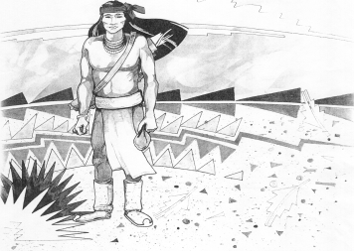

5025 N. Bowie Ave.

P.O. Box 1088

Cochise, AZ 85606

(520) 384-2540 (520) 384-4836 Fax

*Karl Uterhardt, Superintendent*

NOTICE & AGENDA OF GOVERNING BOARD MEETING

COCHISE ELEMENTARY SCHOOL DISTRICT NO. 26

Notice is hereby given that the School District Governing Board will hold a public meeting on

May 3, 2023, at 6:00pm in the Cochise Elementary School Library.

The agenda for the meeting is as follows:

I. Call to Order Time _________

1. Pledge of Allegiance to the Flag
2. Adoption of Agenda Motion ____/____Vote____
3. Call to the Audience (3 minute limit)
4. The Governing Board may vote to go into Executive Session under A.R.S. 38-431.03 (A)(3) to receive legal advice either in person or telephonically, on any item on the Consent or Action agenda.

VI. Consent Agenda

1. Approve minutes of Regular Meeting of April 5, 2023
2. Approve fund balances report for April 2023
3. Approve vouchers #21-22 (Payroll) & #2320-2322 (Expense) Motion ____/____Vote____

1. Action Agenda
2. Mrs. Lori White, 2nd grade teacher Discussion Only
3. Presentation by Mrs. Cristi Swan, Auditor FY22 Discussion Only
4. Approval of FY22 audit Motion____/____ Vote____
5. Approve Expenditure budget #1 Motion____/____ Vote____
6. Discussion/Action possible schedule change for SY23-24 Motion____/____ Vote____

VIII. Summary of reports about current events

A. Superintendent’s Report

1. May calendar of events:

2. Next Board meetings: June 21, July 12, August 2

3. AASA & AzSCI testing update

B. Governing Board member’s report

IX. Adjourn Motion ____/____Vote____ Time ____