# Cochise School District No. 26

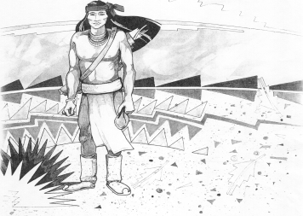

5025 N. Bowie Ave.

P.O. Box 1088

Cochise, AZ 85606

(520) 384-2540 (520) 384-4836 Fax

*Karl Uterhardt, Superintendent*

COCHISE ELEMENTARY SCHOOL DISTRICT NO. 26

Notice is hereby given that the School District Governing Board will hold a public meeting on

December 4, 2024 following the public hearing in the school library, approximately 6:00pm.

The agenda for the meeting is as follows:

I. Call to Order Time _________

1. Pledge of Allegiance to the Flag
2. Adoption of Agenda Motion ____/____Vote____

IV. Call to the Audience (3 minute limit)

1. The Governing Board may vote to go into Executive Session under A.R.S. 38-431.03 (A)(3) to receive legal advice either in person or telephonically, on any item on the Consent or Action agenda

VI. Consent Agenda

1. Approve minutes of Regular Meeting of November 6, 2024
2. Approve fund balances report for November 2024
3. Approve Mr. Robert Spitzer Yearbook editor
4. Approve Mrs. Sabrina Oscar Testing Coordinator
5. Approve vouchers Payroll #10-11 and Expenditure #2510-2511 Motion ____/____Vote____

VII. Action Agenda

1. Mrs. Sabrina Oscar, Special Education Teacher Discussion Only
2. Approve $500.00 one time pay for all non-teaching employees

Mr. Morales, Mrs. Cavey, Mrs. Williammee, Mr. Brown, Mrs. Nohl

Ms. Acuna, Mr. Uterhardt, Mr. AJ Brown (75%), Julia Leksell (40%)

Marie Spitzer (24%) Motion____/____ Vote____

1. Approve Classroom Site Fund payment for all eligible teachers in the amount

Of $3,000.00 Motion___/____ Vote____

1. Approve Classroom site fund payment for Mrs. Aten, Mrs. Rone, Mrs. White

Mrs. Graham, Ms. Estrella, Mr. Spitzer, Mrs. Hirshouer, Mrs. Mascarenas,

and Mrs. Oscar Motion____/____ Vote____

1. Discussion of Superintendent’s Evaluation Discussion only
2. Approval of superintendent's evaluation for 2024-2025 Motion____/____ Vote____

VIII. Summary of reports about current events

A. Superintendent’s Report

1. December calendar of events-December 6th Science Fair 8:00-2:00pm, December 13th Home BB game, December 19th Christmas Concert 6:00pm, December 20th Movie Day all students K-8 will be at the Willcox Theater from 930-1130; December 23-January 3 Christmas Break

2. Future board meeting dates: December 4, January 8, 2025, February 5th

B. Governing Board member’s report

IX. Adjourn Motion ____/____Vote____ Time ____