# Cochise School District No. 26

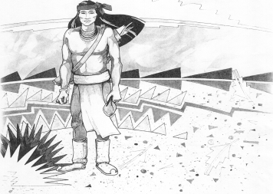

5025 N. Bowie Ave.

P.O. Box 1088

Cochise, AZ 85606

(520) 384-2540 (520) 384-4836 Fax

*Karl Uterhardt, Superintendent*

NOTICE & AGENDA OF GOVERNING BOARD MEETING

COCHISE ELEMENTARY SCHOOL DISTRICT NO. 26

Notice is hereby given that the School District Governing Board will hold a public meeting on

November 1, 2017 at 6:30 pm in the media center. The agenda for the meeting is as follows:

I. Call to Order Time _________

1. Pledge of Allegiance to the Flag
2. Adoption of Agenda Motion ____/____Vote____

IV. Call to the Audience (3 minute limit)

V.The Governing Board may vote to go into Executive Session under A.R.S. §38-431.03 (A)(3) to receive legal advice, either in person or telephonically, on any item on the Consent or Action agenda.

VI. Consent Agenda

1. Approve minutes of Regular Meeting of October 4, 2017
2. Approve fund balances report for October 2017
3. Approve vouchers #8-9 (Payroll) & #1806-1807 (Expense) Motion ____/____Vote____

VII. Action Agenda

1. Approval of Arizona Instruction 1942-A Exhibit E for USDA Grant Motion____/____ Vote____
2. Discussion of Board Evaluation
3. Approval of Board Evaluation Motion____/____ Vote____
4. Discussion Superintendent Evaluation
5. Approval of Superintendent’s Evaluation Motion____/____ Vote____

VIII. Summary of reports about current events

A. Superintendent’s Report

1. November calendar of events

B. Governing Board member’s report

IX. Adjourn Motion ____/____Vote____ Time ____