# Cochise School District No. 26

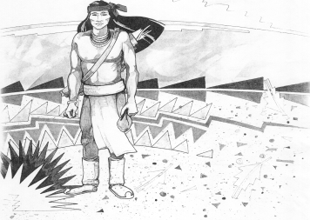

5025 N. Bowie Ave.

P.O. Box 1088

Cochise, AZ 85606

(520) 384-2540 (520) 384-4836 Fax

*Karl Uterhardt, Superintendent*

NOTICE & AGENDA OF GOVERNING BOARD MEETING

COCHISE ELEMENTARY SCHOOL DISTRICT NO. 26

Notice is hereby given that the School District Governing Board will hold a public meeting on

March 6, 2024, at 6:00pm in the Cochise Elementary School Library.

The agenda for the meeting is as follows:

1. Call to Order Time _________
2. Pledge of Allegiance to the Flag
3. Adoption of Agenda Motion ____/____Vote____
4. Call to the Audience (3 minute limit)
5. The Governing Board may vote to go into Executive Session under A.R.S. 38-431.03 (A)(3) to receive legal advice either in person or telephonically, on any item on the Consent or Action agenda.

VII. Consent Agenda

1. Approve minutes of Regular Meeting of February 7, 2024
2. Approve fund balances report for February 2024
3. Policy Advisories 763-786 Omitting 777 as it is a high school requirement
4. Approve vouchers #17-18 (Payroll) & #2315-2316 (Expense) Motion ____/____Vote____

1. Action Agenda
2. Mrs. Linda McCann, 4th grade teacher Discussion Only
3. Approve June 26 board meeting date Motion____/____ Vote____
4. Approve General Statement of Assurance. Motion____/____ Vote____
5. Approve medical, dental, vision plan for 2024-2025 school year Motion____/____ Vote____
6. Approve Ms. Liana Estrella, Teacher for 2024-2025 school year Motion____/____ Vote____

IX. Summary of reports about current events

A. Superintendent’s Report

1. March calendar of events: BB recap; Parent teacher conf. 3/7, early release 3/8, spring break 3/11-3/15, 3/29 Good Friday, AzSCI testing last week in March.

2. Next Board meetings: April 3, May 1, June 26

B. Governing Board member’s report

X. Adjourn Motion ____/____Vote____ Time ____