# Cochise School District No. 26

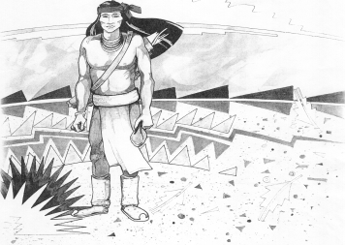

5025 N. Bowie Ave.

P.O. Box 1088

Cochise, AZ 85606

(520) 384-2540 (520) 384-4836 Fax

*Karl Uterhardt, Superintendent*

NOTICE & AGENDA OF GOVERNING BOARD MEETING

COCHISE ELEMENTARY SCHOOL DISTRICT NO. 26

Notice is hereby given that the School District Governing Board will hold a public meeting on

August 2, 2017 at 6:30 pm in the media center. The agenda for the meeting is as follows:

I. Call to Order Time _________

1. Pledge of Allegiance to the Flag
2. Adoption of Agenda Motion ____/____Vote____

IV. Call to the Audience (3 minute limit)

V.The Governing Board may vote to go into Executive Session under A.R.S. §38-431.03 (A)(3) to receive legal advice, either in person or telephonically, on any item on the Consent or Action agenda.

VI. Consent Agenda

A. Approve minutes of Regular Meeting of July 12, 2017

B. Approve fund balances report for July 2017

C. Approve vouchers #2 (Payroll) & #1800-1801 (Expense) Motion ____/____Vote____

VII. Action Agenda

1. Approve Extra duty contracts for:

1. Joaquin Ochoa – Athletic Director Motion____/____ Vote____

2. Robert Spitzer – Yearbook Editor Motion____/____ Vote____

B. Approve Special Education Paraprofessional Motion____/____ Vote____

C. Approve FY2016 Financial Audit Motion ____/____Vote____

D. Discussion/Action – ASBA Core Belief amendment process Motion____/____ Vote____

VIII. Summary of reports about current events

A. Superintendent’s Report

1. August calendar of events

2. School projects update

B. Governing Board member’s report

IX. Adjourn Motion ____/____Vote____ Time ____