# Cochise School District No. 26

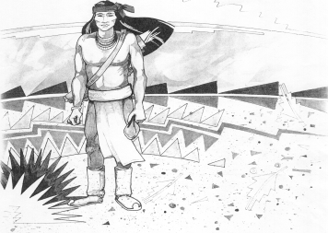

5025 N. Bowie Ave.

P.O. Box 1088

Cochise, AZ 85606

(520) 384-2540 (520) 384-4836 Fax

*Karl Uterhardt, Superintendent*

COCHISE ELEMENTARY SCHOOL DISTRICT NO. 26

Notice is hereby given that the School District Governing Board will hold a public meeting on

November 6, 2024 following the public hearing in the school library, approximately 6:00pm.

The agenda for the meeting is as follows:

I. Call to Order Time _________

1. Pledge of Allegiance to the Flag
2. Adoption of Agenda Motion ____/____Vote____

IV. Call to the Audience (3 minute limit)

1. The Governing Board may vote to go into Executive Session under A.R.S. 38-431.03 (A)(3) to receive legal advice either in person or telephonically, on any item on the Consent or Action agenda

VI. Consent Agenda

1. Approve minutes of Regular Meeting of October 2, 2024
2. Approve fund balances report for October 2024
3. Approve vouchers Payroll #8-9 and Expenditure #2508-2510 Motion ____/____Vote____

VII. Action Agenda

1. Ms. Liana Estrella, 4th grade teacher Discussion Only
2. Approve policy advisories 801-807 second reading Motion____/____ Vote____
3. Approve Classroom Site Fund plan for 2024-2025 school year Motion____/____ Vote____
4. Discussion of Cochise School Performance grade of A for 2024 Discussion only
5. Board reminder the superintendent’s evaluation is due by December 31, 2024 Discussion only

VIII. Summary of reports about current events

A. Superintendent’s Report

1. November calendar of events-Volleyball tournament results, No school November 11th for Veteran’s Day and November 27-29 for Thanksgiving. First BB game November 15th; first home game November 22nd.

2. Future board meeting dates: December 4, January 8, 2025, February 5th

B. Governing Board member’s report

IX. Adjourn Motion ____/____Vote____ Time ____