# Cochise School District No. 26

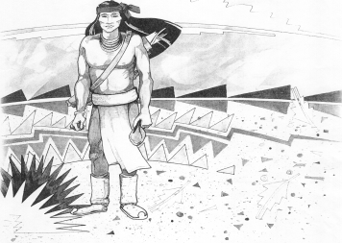

5025 N. Bowie Ave.

P.O. Box 1088

Cochise, AZ 85606

(520) 384-2540 (520) 384-4836 Fax

*Karl Uterhardt, Superintendent*

NOTICE & AGENDA OF GOVERNING BOARD MEETING

COCHISE ELEMENTARY SCHOOL DISTRICT NO. 26

Notice is hereby given that the School District Governing Board will hold a public meeting on

February 1, 2023, at 6:00pm in the Cochise Elementary School Library.

The agenda for the meeting is as follows:

I. Call to Order Time _________

1. Pledge of Allegiance to the Flag
2. Adoption of Agenda Motion ____/____Vote____
3. Call to the Audience (3 minute limit)
4. The Governing Board may vote to go into Executive Session under A.R.S. 38-431.03 (A)(3) to receive legal advice either in person or telephonically, on any item on the Consent or Action agenda.

VI. Consent Agenda

1. Approve minutes of Regular Meeting of January 11, 2023
2. Approve fund balances report for January 2023
3. Approve vouchers #15-16 (Payroll) & #2313-2314 (Expense)
4. Approve corrected minutes from November 2, 2022
5. Approve corrected minutes from April 1, 2020
6. Approve the engagement letter for our annual audit ending June 30, 2022
7. Policy advisories 739-743 first reading
8. Approve facilities use agreement using the gym on July 15, 2023 Motion ____/____Vote____

1. Action Agenda
2. Mrs. Tina Mascarenas & Mrs. Libby Wilson Discussion Only
3. Approve Certified Teacher contract for Ms. Sabrina Gomez Motion____/____ Vote____
4. Acceptance of donation of $2,476.00 from Western Bank Motion____/____ Vote____
5. Discussion/Action of Mrs. Cheri Williammee’s intent to retire May 26, 2023 and

continue working for Cochise ESD #26 as bus driver & special education

paraeducator under Educational Services Inc., effective August 7, 2023 Motion____/____ Vote____

1. Approve District calendar for 2023-2024 Motion____/____ Vote____
2. Discuss/Approve Project Alert with La Frontera-Southeastern Arizona Behavioral

Health Services to expand accessibility via technology Motion____/____ Vote____

1. Approve Extra Duty contract for Tina Mascarenas, Knowledge Bowl Coach $350 Motion____/____ Vote____

VIII. Summary of reports about current events

A. Superintendent’s Report

1. February calendar of events:

2. Next Board meetings: March 1, April 5, May 3

B. Governing Board member’s report

IX. Adjourn Motion ____/____Vote____ Time ____