# Cochise School District No. 26

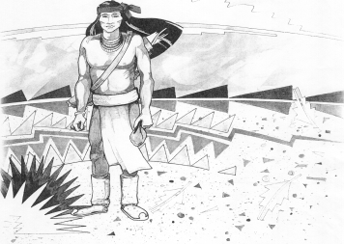

5025 N. Bowie Ave.

P.O. Box 1088

Cochise, AZ 85606

(520) 384-2540 (520) 384-4836 Fax

*Karl Uterhardt, Superintendent*

NOTICE & AGENDA OF GOVERNING BOARD MEETING

COCHISE ELEMENTARY SCHOOL DISTRICT NO. 26

Notice is hereby given that the School District Governing Board will hold a public meeting on

September 6, 2023 following the public hearing in the media center, approximately 6:00pm.

The agenda for the meeting is as follows:

I. Call to Order Time _________

1. Pledge of Allegiance to the Flag
2. Adoption of Agenda Motion ____/____Vote____

IV. Call to the Audience (3 minute limit)

1. The Governing Board may vote to go into Executive Session under A.R.S. 38-431.03 (A)(3) to receive legal advice either in person or telephonically, on any item on the Consent or Action agenda

VI. Consent Agenda

1. Approve minutes of Regular Meeting of August 2, 2023
2. Approve fund balances report for August 2023
3. Approve vouchers Payroll #4-6 and Expenditure #2401-2403
4. Declare old items in the maintenance storage room as trash. Motion ____/____Vote____

VII. Action Agenda

1. Mrs. Cori Aten Kindergarten teacher Discussion Only
2. Discussion of SPED for 2023-24 Motion____/____ Vote____
3. Discussion/Action Lori White attending the National Rural School Conf. in

Chattanooga, TN November 15-17 cost of $400.00 Motion____/____ Vote____

1. Discussion/Action of response from ADOT Motion____/____ Vote____
2. Gym floor update Discussion Only

VIII. Summary of reports about current events

A. Superintendent’s Report

1. September calendar of events-Away VB games Sept. 8, 15 19, home on Sept. 29; KB Sept. 18 @Pomerene; Flag retirement ceremony on Sept. 14th 8:10am

2. Future board meeting dates: October 4, November 1, December 6

B. Governing Board member’s report

IX. Adjourn Motion ____/____Vote____ Time ____