# Cochise School District No. 26

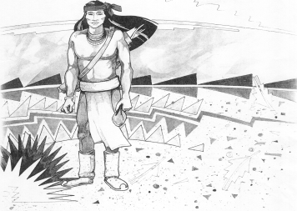

5025 N. Bowie Ave.

P.O. Box 1088

Cochise, AZ 85606

(520) 384-2540 (520) 384-4836 Fax

*Karl Uterhardt, Superintendent*

NOTICE & AGENDA OF GOVERNING BOARD MEETING

COCHISE ELEMENTARY SCHOOL DISTRICT NO. 26

Notice is hereby given that the School District Governing Board will hold a public meeting on

May 1, 2024, at 6:00pm in the Cochise Elementary School Library.

The agenda for the meeting is as follows:

I. Call to Order Time _________

1. Pledge of Allegiance to the Flag
2. Adoption of Agenda Motion ____/____Vote____
3. Call to the Audience (3 minute limit)
4. The Governing Board may vote to go into Executive Session under A.R.S. 38-431.03 (A)(3) to receive legal advice either in person or telephonically, on any item on the Consent or Action agenda.

VI. Consent Agenda

1. Approve minutes of Regular Meeting of April 3, 2024
2. Approve fund balances report for April 2024
3. Approve extra duty contract for Ms. Sabrina Gomez, Technology

Coordinator for the AASA testing

1. Approve vouchers #20-22 (Payroll) & #2419-2421 (Expense) Motion ____/____Vote____

1. Action Agenda
2. Mrs. Libby Wilson, Science teacher Discussion Only
3. Approve FY2324 Expenditure Budget revision #2 Motion____/____ Vote____
4. Approve Ms. Liana Estrella, Teacher for 2024-2025 school year Motion____/____ Vote____
5. Presentation by Mrs. Cristi Swan, for Cochise School Audit FY23 Discussion Only
6. Approve Cochise School Financial Audit for Fiscal Year 2023 Motion____/____ Vote____
7. Approve Superintendent Performance Pay FY2023-2024 Motion____/____ Vote____

VIII. Summary of reports about current events

A. Superintendent’s Report

1. May calendar of events:

2. Next Board meetings: June 26, July 10, August 7

3. AASA & AzSCI testing update

B. Governing Board member’s report

IX. Adjourn Motion ____/____Vote____ Time ____