# Cochise School District No. 26

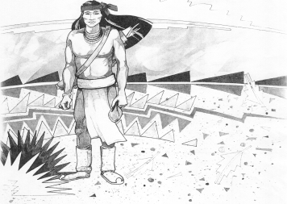

5025 N. Bowie Ave.

P.O. Box 1088

Cochise, AZ 85606

(520) 384-2540 (520) 384-4836 Fax

*Karl Uterhardt, Superintendent*

NOTICE & AGENDA OF GOVERNING BOARD MEETING

COCHISE ELEMENTARY SCHOOL DISTRICT NO. 26

Notice is hereby given that the School District Governing Board will hold a public meeting on

February 5, 2025, at 6:00pm in the Cochise Elementary School Library.

The agenda for the meeting is as follows:

I. Call to Order Time _________

1. Pledge of Allegiance to the Flag
2. Adoption of Agenda Motion ____/____Vote____
3. Call to the Audience (3 minute limit)
4. The Governing Board may vote to go into Executive Session under A.R.S. 38-431.03 (A)(3) to receive legal advice either in person or telephonically, on any item on the Consent or Action agenda.

VI. Consent Agenda

1. Approve minutes of Regular Meeting of January 8, 2025
2. Approve fund balances report for January 2025
3. Approve vouchers #15-17 (Payroll) & #2514-2515 (Expense) Motion ____/____Vote____

1. Action Agenda
2. Ms. Sabrina Oscar discussion with the Board Discussion Only
3. Approve Certified salary schedule SY2025-2026 Motion____/____ Vote____
4. Superintendent’s Evaluation discussion Discussion Only
5. Approve Superintedent’s Evaluation for SY24-25 Motion____/____ Vote____

VIII. Summary of reports about current events

A. Superintendent’s Report

1. February calendar of events: BB game Feb . 7, No School Feb. 17, BB tournaments Feb. 21 girls, Feb. 22 boys

2. Next Board meetings: March 5, April 2, May 7

B. Governing Board member’s report

IX. Adjourn Motion ____/____Vote____ Time ____