# Cochise School District No. 26

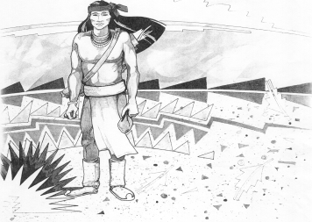

5025 N. Bowie Ave.

P.O. Box 1088

Cochise, AZ 85606

(520) 384-2540 (520) 384-4836 Fax

*Karl Uterhardt, Superintendent*

NOTICE & AGENDA OF GOVERNING BOARD MEETING

COCHISE ELEMENTARY SCHOOL DISTRICT NO. 26

**Notice is hereby given that the School District Governing Board will hold a public meeting on**

**May 2, 2018 at 6:30 pm in the media center. The agenda for the meeting is as follows:**

I. Call to Order Time _________

1. Pledge of Allegiance to the Flag
2. Adoption of Agenda Motion ____/____Vote____
3. Call to the Audience (3 minute limit)
4. The Governing Board may vote to go into Executive Session under A.R.S. §38-431.03 (A)(3) to receive legal advice, either in person or telephonically, on any item on the Consent or Action agenda.

VI. Consent Agenda

1. Approve minutes of Regular Meeting of April 4, 2018

B. Approve fund balances report for April 2018

C. Approve vouchers #21-22 (Payroll) & #1819-1820 (Expense)

D. Approve Mrs. Carolyn Lowrey, school bus driver for 2018-19. Motion ____/____Vote____

VII. Action Agenda

1. Approval of Mr. Uterhardt’s Performance Pay 2017-18 Motion____/____ Vote____
2. Approval of Project AMOR facilities use form for this summer Motion____/____ Vote____
3. Approval of Ms. Sabrina Gomez SPED paraeducator 2018-19 Motion____/____ Vote____
4. Approval of Classroom site fund payment for teachers 5/18/18 Motion____/____ Vote____
5. Discussion of policy JFB open enrollment (Discussion Only)
6. Approval of second reading of policy JFB open enrollment Motion____/____ Vote____
7. Approve Mr. Uterhardt’s performance goals 2018-2021 Motion____/____ Vote____

1. Attend at least three (3) educational conferences per year (25%),

2. Parent surveys will grade out at Good (B) or better in at least 70% of the returned surveys. (25%),

3. Demonstrate one (1) year’s growth in student reading and math as a district. (25%),

4. Complete all staff evaluations on time. (25%)*.*

1. Approve Revised FY1718 Expenditure Budget Motion____/____ Vote____
2. Continuing Resolution with Cochise County Treasurer Motion____/____ Vote____
3. Approve June/July Board meeting dates 6/27 & 7/11 Motion____/____ Vote____

VIII. Summary of reports about current events

A. Superintendent’s Report

1. May calendar of events

2. Promotion May 24, 2018 at 7pm

B. Governing Board member’s report

IX. Adjourn Motion ____/____Vote____ Time ____