# Cochise School District No. 26

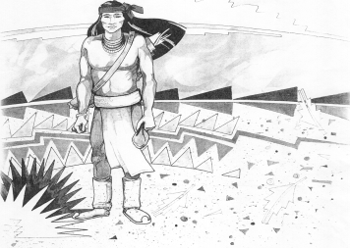

5025 N. Bowie Ave.

P.O. Box 1088

Cochise, AZ 85606

(520) 384-2540 (520) 384-4836 Fax

*Karl Uterhardt, Superintendent*

COCHISE ELEMENTARY SCHOOL DISTRICT NO. 26

Notice is hereby given that the School District Governing Board will hold a public meeting on

September 4, 2024 following the public hearing in the media center, approximately 6:05pm.

The agenda for the meeting is as follows:

I. Call to Order Time _________

1. Pledge of Allegiance to the Flag
2. Adoption of Agenda Motion ____/____Vote____

IV. Call to the Audience (3 minute limit)

1. The Governing Board may vote to go into Executive Session under A.R.S. 38-431.03 (A)(3) to receive legal advice either in person or telephonically, on any item on the Consent or Action agenda

VI. Consent Agenda

1. Approve minutes of Regular Meeting of August 7, 2024
2. Approve fund balances report for August 2024
3. Approve vouchers Payroll #4-5 and Expenditure #2504-2505
4. Declare freezer in cafeteria kitchen as trash/auction item Motion ____/____Vote____

VII. Action Agenda

1. Mrs. Lori White, 2nd grade teacher Discussion Only
2. Approve Superintendent’s performance goals 2024-2025 Motion____/____ Vote____
3. Approve Policy Advisories 788-800 First reading (Omit 796 HS Grad) Motion____/____ Vote____
4. Approve Mrs. Lori White AFA National Conference National Harbor, MD

September 14-15, 2024 No cost to the district Motion____/____ Vote____

1. Approve conflict of interest forms for Board members Motion____/____ Vote____

VIII. Summary of reports about current events

A. Superintendent’s Report

1. September calendar of events-Volleyball games on Fridays

2. Future board meeting dates: October 2, November 6, December 4

B. Governing Board member’s report

IX. Adjourn Motion ____/____Vote____ Time ____